**National Public School, Koramangala 2021-22**

**Computer Science Assignment -3**

**Iterative Statements**

**Grade: 11**

Write Python scripts for the following:

1. Accept a number n and display the first n terms of Fibonacci series.
2. Accept amount from the user and print the minimum number of notes (Rs. 500, 100, 50, 20, 10, 5, 2, 1) required to represent the amount.

Example:

Input amount: 575

Expected Output:

Amount: 575

Minimum number of notes:

500: 1

50: 1

20: 1

5: 1

1. Accept a number and check whether it is a perfect number or not.

Note: Perfect number is a positive integer that is equal to the sum of its proper divisors. For example, 6 is a perfect number, since it is the sum of 1, 2, and 3.

1. Accept n and print the list of all prime numbers <=n.
2. Accept n, x and find the sum of the following series:

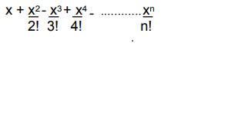



1. Display the following number pattern. Accept the number of rows from the user:

1

1 2 1

1 2 4 2 1

1 2 4 8 4 2 1

1 2 4 8 16 8 4 2 1

1. Write code to create a checkerboard pattern with the words "black" and "white".

Input number of rows: 5

Sample Output:  
black-white-black-white-black  
white-black-white-black-white  
black-white-black-white-black  
white-black-white-black-white  
black-white-black-white-black

***************************